- 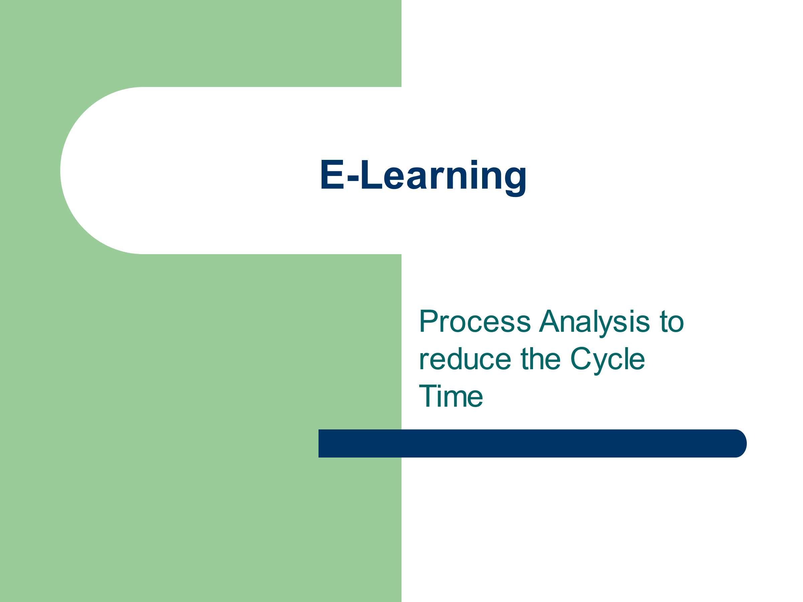

eLearning Course Title: PROCESS ANALYSIS TO REDUCE THE CYCLE TIME.

eLearning Course Type: Free or Paid: Paid

If Paid, Registration Fee (including GST):-Rs 1500/-(Rupees Fifteen Hundred only) per participant

Course conducted by Group/ Regional Directorate Name:- RD, Chandigarh

Name & Designation of Course Coordinator: Mr. Suvyendu Shivakar, Assistant Director

Course Coordinator Contact Details: Mr. Suvyendu Shivakar, Assistant Director , suvyendu.s@npcindia.gov.in, Mobile: 6287872655 and Mr. S.P.Singh, Regional Director, sp.singh@npcindia.gov.in, Mobile-7589219766

eLearning Program Start Date: 19/05/2021|

eLearning Duration: 5 days

About eLearning Program (Brief One para): -One management tool that has proven successful at eliminating waste and improving performance for small and mid-sized manufacturers is Cycle Time Reduction (CTR). CTR consists of speeding a company's order-to-delivery time to get product into the customer's hands expeditiously, at the lowest possible cost.
Cycle time reduction benefits include faster time-to-market and, if other cost factors are kept in check, an opportunity for higher profitability. Cycle time reduction also helps a company be more competitive against other businesses that offer similar products to the same customer base.

Higher Productivity means to do more, better and faster with less. The more part refers to increasing production; better means constantly improving quality, faster involves reducing cycle time, and less means cutting costs. To achieve this goal, companies have enacted a number of surprisingly similar initiatives, many companies have also been in an almost continuous state of reorganization trying to attain the optimal structural configuration. Unfortunately, the outcome of all the initiatives is that today, most of easy, low hanging fruits have already been picked. Committed to continuous improvement at both micro and macro levels, they are now searching of next level in improvement journey. Cycle time reduction is to provide some direction for this next corporate step. It cuts the theory of why we should ding something, and instead provides some real insights into, how we can do something; insights that include a variety of tools, techniques and practical tips for reducing the cycle time of any process / work activity.

The e-learning course aims to describe methods of process analysis and impart knowledge about tools & techniques to reducing the cycle time of various processes .

eLearning Course Coverage (Specify Module details) :-

Module-1: Speed & Technology
Module-2: Process Analysis
Module-3: Resource Availability
Module-4: Continuous flow
Module-5: Cross functional Team & Activity based work design.

Register to learn (Key Learning’s’ in bullet points):

- Basics of Cycle time Reduction
- Process Analysis Work sheet
- Resource Availability & Accessibility
- Capacity & Layout Planning
- Cross Functional Team & Process design

Register in advance for this eLearning program:

Registration Start Date:19/05/2021

Registration End Date: -open

Thanks and regards

S.P.Singh
Regional Director
National Productivity Council, Chandigarh
SCO-40, First Floor, Sector 7-C, Chandigarh
Website: www.npcindia.gov.in

